Kaarel Part

Documentation for the investigation portion of the NEA coursework
Investigation
Computer Science NEA

Table of Contents
Desk based research 3
Example 1: Robin Powered 3
Example 2: Eptura Engage 4
Example 3: Envoy Hot Desks 5
Stakeholders 6
Administrative Staff 6
General staff (employees/meeting organisers) 6
Managers/senior staff 7
It department 7
Investigation Method 1 7
Prerequisites 7
Format of the Questionnaire for Employees 7
Format of questionnaire for administration 8
Results 8
Employee questionnaire result 8
Administration questionnaire result 10
Analysis of results 12
Investigation Method 2 13
Prerequisites 13
Employee Interview Questions 13
Admin Team Interview Questions 14
The interviews 14
Interview with Employee 14
Interview with Admin Team 14
Analysis of results 15
Investigation Method 3 16
Plan 16
Going In 16
Analysis of results 16
Document Collection 16
Scans + Annotation 17
Processing 21
Limitations 22
Working specification 22
Justifications of the methods to be used. 23
What language are you planning on using and why? 23
What libraries will you be using and why? 23
What methods are you planning on using? 23
What SQL platform are you planning on using and why? 23
Objectives and success criteria 24
Objectives 24
Success Criteria 24

Desk based research

Example 1: Robin Powered
Robin Powered, founded in 2014, offers workplace management software for optimising office spaces, featuring desk booking systems (efficient space allocation), meeting room schedulers (streamlined room reservations), real-time occupancy tracking (accurate usage insights), and analytics dashboards (data-driven decisions).
The main good thing about Robin Powered is that it is built as an add-on for businesses into their current infrastructure instead of being a separate page, meaning it is extremely easy to use for the users in the business. Even if the initial links to all the different websites in development are difficult to link up with everything, I think the product with it being linked directly to existing solutions is probably as easy as you can make all of this. However, as I said before, the project being only internal and not having such a large scope where I’ll make integration with every platform like Teams, Slack, etc., I won’t have this

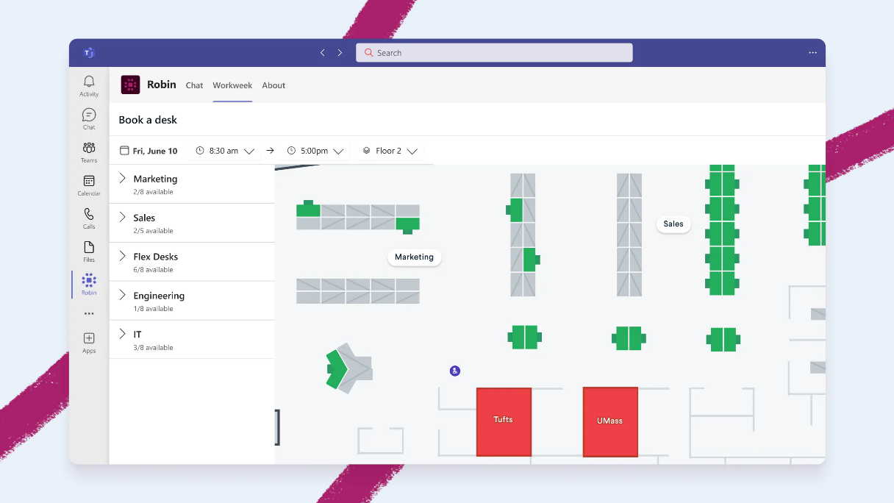
Already integrated into existing solutions e.g. teams
Drag and drop Seat layout
Robin Powered also has an AI assistant. Self-hosting an LLM requires significant compute, especially with many users, which can exponentially increase costs. Alternatively, API keys from providers like OpenAI can be expensive. However, the significant problems it solves are worth it. Instead of navigating menus, especially if the booking system is added in the direct phase over, where users have no idea where anything is and so reduce productivity , they can simply specify where, when, and where they want their meeting, and the AI assistant will handle it for them, making it a very useful feature to have; however, due to the amount of compute this requires, it won’t be in my project sadly.
Furthermore, I also like the drag-and-drop meeting room layout maker. The user-friendly interface makes it easy to add the room layout into the system, and it clearly conveys where everyone should sit to everyone. My system will include this as well; however, it won’t probably be as nice as this since I haven’t worked as much with dynamic web content besides buttons, so I don’t know how difficult dragging items is.
However, one thing I don't like about this system is that for check-in it relies on a phone app instead of a physical thing to check in on. Sure, most of the users will have a phone if they work in this sector; however, I believe that this booking system should have at least a way to physically check in too, since if they don’t know how to log in or, worse, even install the app on the phone or don’t have it on them or it’s dead, it ruins having this system anyway and falls back to manual signing in, which takes up admins' time. Obviously, I will not have this; instead, as said before I’ll have a physical screen that needs to be checked in on either via NFC or inputting their employee ID in.

Example 2: Eptura Engage
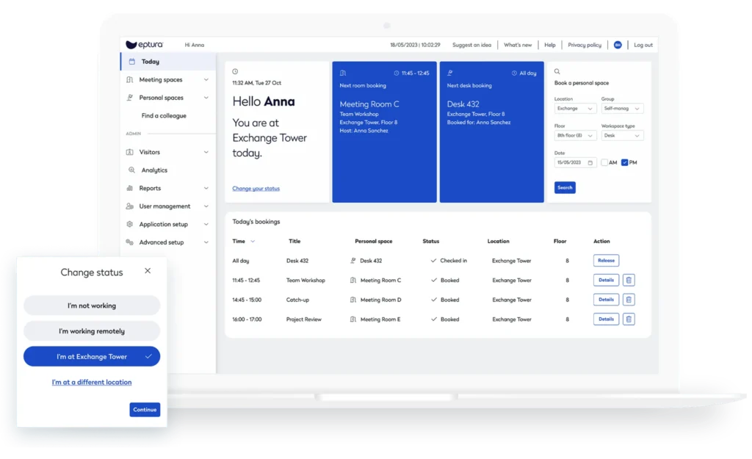
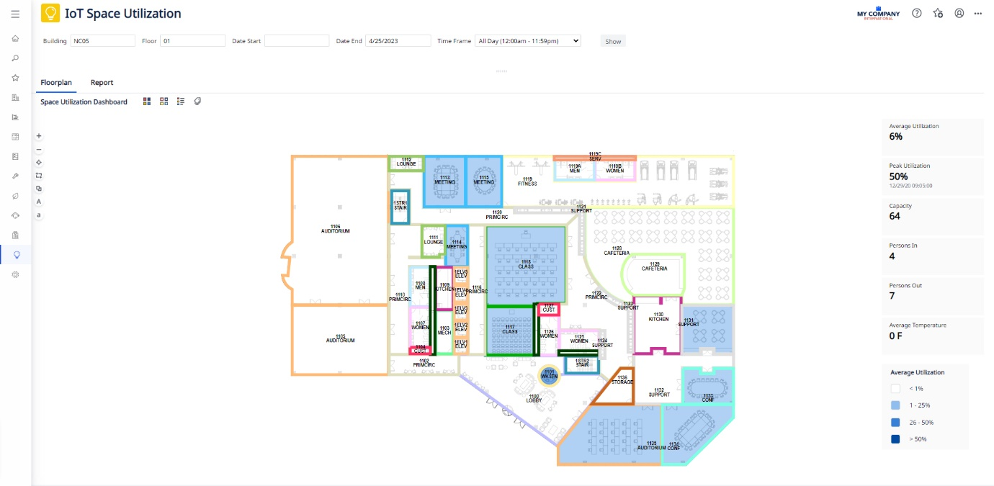
Controls to see specific areas on map
Nice to see analytics of office to see where shortcomings are
Eptura Engage, formerly known as Condeco, is a workplace management platform that focuses on optimising office space and hybrid work environments. It provides desk booking, meeting room scheduling, interactive office maps, occupancy tracking, and calendar integration. One of the main good things about Eptura Engage is the interactive office map. Users can see available desks and rooms in real time, which makes finding a space very intuitive. My system will include a similar feature, though it might not be as polished as Eptura’s since I haven’t worked extensively with dynamic office layouts yet. I also like that Eptura integrates with calendar systems like Outlook and Google Calendar. This makes it very easy for employees to manage bookings without switching between different tools. I will try to include basic calendar integration in my system as well, as it improves user convenience. Another useful feature is the automated check-in using badge swipes or sensors. This ensures accurate tracking of space usage without requiring extra input from the employee. However, my system will not include this, as I plan to rely on a simple physical screen for check-ins via NFC or employee ID input instead. This keeps costs lower and the setup simpler for a small-scale implementation. One thing I don’t like about Eptura Engage is that it can be overly complex for smaller teams. There are a lot of options and settings, which might confuse users who just want a simple booking system. My design will focus on keeping the interface straightforward and user-friendly, without unnecessary complexity.

Example 3: Envoy Hot Desks
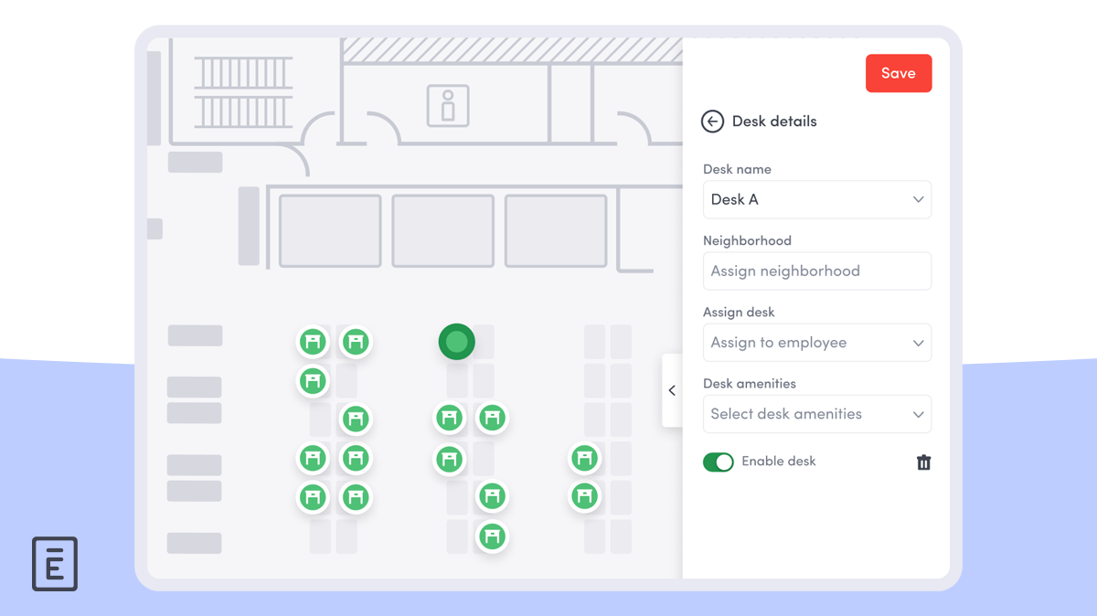
Envoy is a workplace management platform that provides hot desk booking, meeting room scheduling, mobile access, and integration with tools like Outlook and Google Calendar. One thing I like about Envoy is its user-friendly interface. It’s very intuitive, making it easy for employees to book desks or manage their reservations without much guidance. My system will also aim to be simple and easy to use, though it might not be as polished as Envoy’s interface since this is also using some extra web tech that I just can’t do with pure python e.g. react, shadcn tailwind etc. I also like that Envoy is mobile-friendly. Users can make bookings on-the-go from their phones, which is especially useful for hybrid working teams. I will include mobile accessibility when using the website in a browser in my design, so employees are not limited to just a desktop interface. Integration with calendar systems is another useful feature. Being able to view and manage bookings directly from Outlook or Google Calendar helps prevent double-bookings and saves time. I will include basic calendar integration in my project as well. One thing I don’t like about Envoy is that it relies entirely on digital tools. If someone doesn’t have a phone, or their internet connection is unreliable, they may not be able to book or check in easily. For this reason, my system will include a physical check-in screen using NFC or employee ID input to ensure bookings are still manageable offline.

Stakeholders

Administrative Staff
The administrative staff currently handle booking requests through a mix of emails, paper forms, and even verbal communication, which makes the process slow and error prone. Their main requirement is a system that will significantly reduce their workload by automating bookings, checking for clashes, and minimising the risk of double reservations. They would benefit from tools that allow them to oversee bookings without having to manually update lists or chase staff for confirmation. To research their needs, questionnaires and targeted interviews can be conducted to uncover the specific pain points in their daily tasks, while observation of their current workflow would give insight into where time is lost and errors most often occur.

General staff (employees/meeting organisers)
The general staff are the most frequent users of the system, as they need to book rooms for everyday meetings, training sessions, and consultations with colleagues or external visitors. Their primary requirement is quick and convenient access to real-time availability, allowing them to manage their own bookings without constant dependence on administrators. To investigate their needs, questionnaires distributed across departments will help capture booking habits, frustrations with the current system, and expectations for a digital platform. Usage data gathered through observation could also highlight the most common booking patterns and identify features that would be most valuable.

Managers/senior staff
Managers and senior staff require a slightly different level of access, as they often need oversight of room usage across multiple teams and sometimes require the ability to override bookings when higher-priority meetings arise. Their requirement is therefore a system that provides them with advanced permissions, including access to full meeting details and the capacity to make or adjust bookings at a departmental level. They also need the reassurance that the platform will support organisational hierarchy by respecting seniority while maintaining fairness. To research their requirements, interviews would be the most effective method, as managers can provide detailed feedback on how often they encounter conflicts, how they currently resolve them, and what additional functionality would help them perform their role more efficiently.

It department
The IT department plays a vital role in setting up, maintaining, and securing the system within the CAA’s internal infrastructure. Their requirements include ensuring the platform complies with GDPR by handling personal and meeting data responsibly, as well as maintaining system reliability and uptime. They will also expect the system to work seamlessly on authorised company devices and not introduce unnecessary technical complications. For the investigation, consultations and interviews with IT staff would be most appropriate, as they can provide technical specifications, highlight integration challenges, and outline security standards that must be followed. This will help ensure the design meets both functional and compliance needs.

Investigation Method 1

Prerequisites
My first investigation method will be a questionnaire. This will be given to all the current workers in the form of a google form they can fill out. There will also be another google form given to the admin that manage the current meeting room booking system manually with paper that will include everything that the normal employee has and extra related to the managing backend side of things.

Format of the Questionnaire for Employees
Question | Options
What is your Employee ID? | (Fill in ID)
How many meetings do you typically book per month? | 1-3, 4-6, 7-10, 11+
How far in advance do you typically book a meeting room? | Less than 1 day, 1-3 days, 4-7 days, more than 7 days
How often do you experience difficulties booking a meeting room at your preferred time? | Frequently, Occasionally, never
On average, how much of the room’s space is used for your meetings? | 0-25%, 26-50%, 51-75%, 76-100%
What is the typical duration of your meetings? | Less than 30 minutes, 30-60 minutes, 1-2 hours, 2+ hours
How often do you make double bookings? | Frequently, Occasionally, never
How often do you need to communicate with admin staff about your booking? | Frequently, Occasionally, never
How satisfied are you with the current room booking system? | Very satisfied, Satisfied, Neutral, Unsatisfied, very unsatisfied
How likely are you to use a digital meeting room booking system? | Highly Likely, Neutral, Unlikely, very unlikely

Format of questionnaire for administration
Question | Options
What is your Employee ID? | (Fill in ID)
How many meetings do you have to set up in terms of administration in a day? | 1-3, 4-6, 7-10, 11+
How much time does it typically take to process a single booking request? | Less than 5 minutes, 5–10 minutes, 11–20 minutes, 20+ minutes
How often do you meet double bookings or scheduling conflicts? | Frequently, Occasionally, never
How often do you receive incomplete or unclear booking requests? | Frequently, Occasionally, never
How often do you have to manually correct or amend bookings after they have been made? | Frequently, Occasionally, never
On average, how many cancellations or changes do you need to process per week? | 0–2, 3–5, 6–10, 11+
How satisfied are you with the current manual booking process? | Very satisfied, Satisfied, Neutral, Unsatisfied, very unsatisfied
How likely are you to use a digital meeting room booking system if it reduces your workload? | Highly Likely, Neutral, Unlikely, very unlikely

Results

Employee questionnaire result

Question | Results
How many meetings do you typically book per month? | 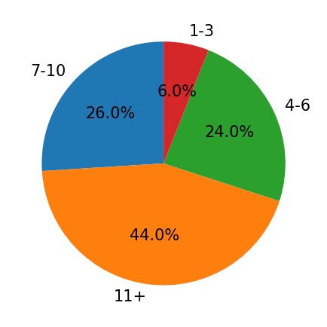
How far in advance do you typically book a meeting room? | 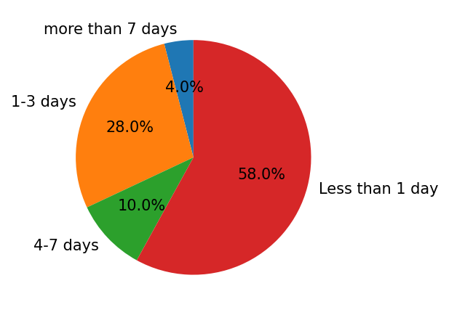
How often do you experience difficulties booking a meeting room at your preferred time? | 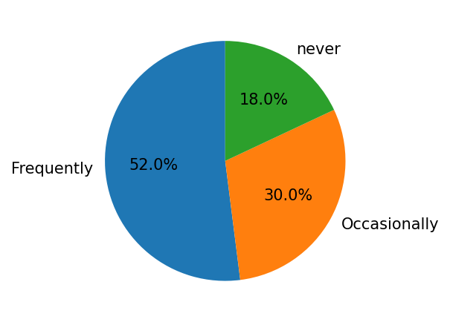
On average, how much of the room’s space is used for your meetings? | 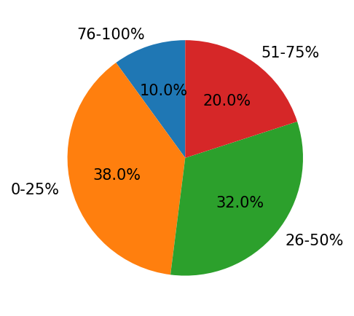
How satisfied are you with the current room booking system? | 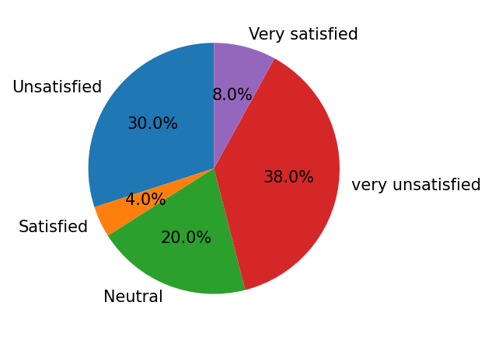

Administration questionnaire result
Question | Results
How many meetings do you have to set up in terms of administration in a day? | 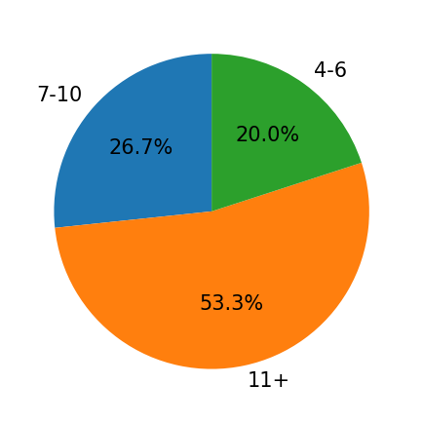
How much time does it typically take to process a single booking request? | 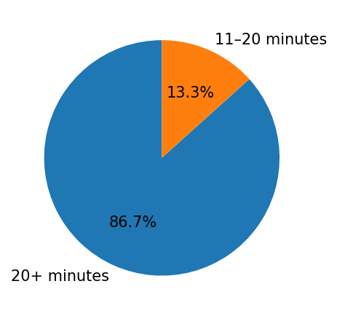
How often do you encounter double bookings or scheduling conflicts? | 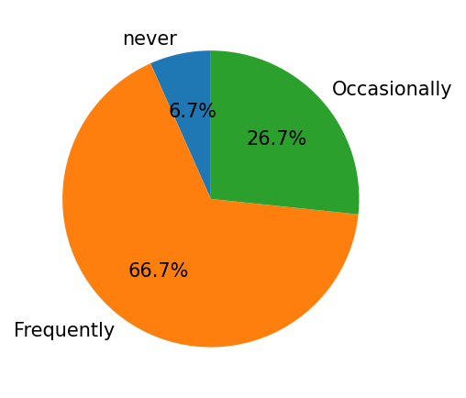
How often do you receive incomplete or unclear booking requests? | 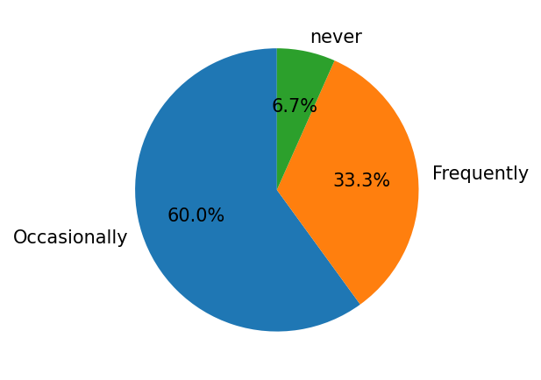
How satisfied are you with the current manual booking process? | 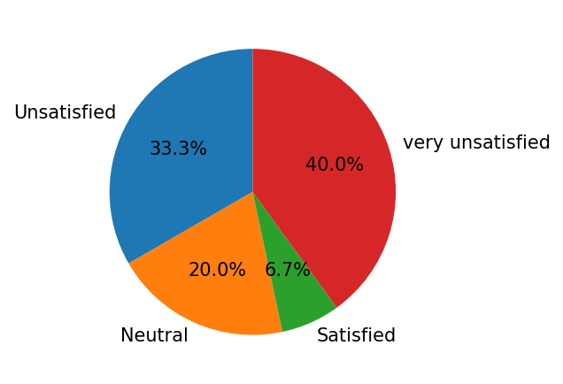

Analysis of results
The questionnaire results from employees highlighted several key patterns in meeting room usage and the limitations of the current manual system. Most staff indicated that they book between 4–10 meetings per month, showing a moderate but consistent demand for meeting spaces. Most bookings were made 1–3 days in advance, indicating that the need for rooms is often short-term and reactive rather than planned far in advance. This pattern underlines the necessity for a system that provides real-time availability, as staff frequently need to make last-minute arrangements. Additionally, a considerable proportion of employees reported frequent or occasional difficulties in securing a room at their preferred time, reinforcing the problem of double bookings and limited visibility inherent in the manual process. The results also revealed that meeting occupancy varied, with most employees using 50–75% of the room’s space, suggesting that the rooms are moderately utilised but often not to full capacity. Staff satisfaction with the current manual system was low, with many expressing frustrations at the cumbersome booking process. Importantly, the responses indicated a high willingness to adopt a digital meeting room booking system, which confirms the feasibility and potential positive reception of the proposed digital solution. From the administrative perspective, the questionnaire results reflected the substantial time and effort required to process bookings manually. Administrators commonly manage 4–6 bookings per day, with processing times ranging from 5–20 minutes per booking. They frequently encounter double bookings, incomplete requests, and scheduling conflicts, highlighting both the inefficiency of manual tracking and the high potential for human error. Satisfaction with the current system was low, yet administrators expressed strong interest in a digital solution that could automate conflict checks, streamline booking management, and reduce workload. Taken together, the data from both employees and administrators clearly demonstrate that the current system is inefficient, error-prone, and time-consuming. The recurring issues of double bookings, lack of live availability, and high administrative effort align closely with the project’s initial problem statement. Overall, the questionnaire confirms that there is a strong need for a real-time, user-friendly digital booking system.

Investigation Method 2
My second investigation method is an interview or rather interviews. One with an employee and one with the admin team. This will involve getting qualitative data since the investigation method 1 (the questionnaire) collected a lot of quantitative data already and this will allow me to get the more personal perspective of the actual system in place from the people who use it.

Prerequisites

Employee Interview Questions
- How do you currently book a meeting room?
- What problems do you usually face when booking?
- How easy is it to check which rooms are available?
- How often do double bookings affect you?
- Would you like to be able to change or cancel your own bookings?
- What would make a digital system most useful for you?

Admin Team Interview Questions
- Can you explain the steps you take to process a booking request?
- What parts of the process take the most time?
- How often do you deal with double bookings or errors?
- What is the hardest part about handling cancellations or changes?
- What features would most reduce your workload in a digital system?
- What concerns would you have about moved to a fully digital system?

The interviews

Interview with Employee
Q: How do you currently book a meeting room?
A: Now, I usually email the admin team with the time and date I need, or I fill out one of the paper forms if I happen to be near their office. If I’m in a rush, I’ll just go and ask them directly. It feels a bit old-fashioned, and it depends on whether they’re free at the time.
Q: What problems do you usually face when booking?
A: The biggest issue is not knowing what’s available in real time. I might request a room, only to be told it’s already taken. Sometimes I end up going back and forth with the admin team suggesting different times until we finally find something that works. It wastes quite a bit of time, especially if I’m trying to organise a meeting with several people.
Q: How easy is it to check which rooms are available?
A: Not easy at all. The only real option is walking over to look at the noticeboard, and even then, it might not be completely accurate because the admin team could still be updating it. If you’re not near the office, you just must wait until the admin staff reply to your request.
Q: How often do double bookings affect you?
A: It does happen. I’d say at least once or twice a month I’ll show up to a room and someone else is already in there with their team. Usually, we either must relocate or one of us cancels, but it’s very disruptive. It makes it hard to rely on the system.
Q: Would you like to be able to change or cancel your own bookings?
A: Absolutely. Right now, if I need to move a meeting or cancel it, I must go back to the admin staff again. It’s slow, and sometimes they don’t get the message straight away. Being able to just log in and do it myself would save a lot of hassle.
Q: What would make a digital system most useful for you?
A: The main thing would be being able to see which rooms are free instantly. I’d also want it to be quick and straightforward to book, cancel, or edit a meeting without relying on someone else. If it could send me a confirmation straight away, that would give me peace of mind. Honestly, if it’s simple and reliable, I’d use it all the time.

Interview with Admin Team
Q: Can you explain the steps you take to process a booking request?
A: Usually, a staff member sends me an email, fills in a paper form, or sometimes just tells me in person. I then check the noticeboard or my own notes to see if the room is available at the time they want. If it’s free, I add the booking to the schedule manually, then confirm back to them, usually with an email. If it isn’t free, I must go back to them and suggest alternatives until we find a slot that works.
Q: What parts of the process take the most time?
A: Chasing missing information is probably the worst. A lot of the time people forget to include key details like the number of attendees or how long they’ll need the room. I then must go back and forth with them, which slows everything down. The other time-consuming bit is when there are last-minute changes—I must manually update everything and notify the people involved.
Q: How often do you deal with double bookings or errors?
A: Often. It’s not unusual for someone to think they’ve got a room only for me to realise later that another booking slipped through at the same time. I’d say it happens a few times every week. It’s frustrating for staff, and it makes me feel like I’m firefighting all the time instead of staying on top of the schedule.
Q: What is the hardest part about handling cancellations or changes?
A: People often cancel at the last minute, or sometimes they don’t even tell us at all. That means the schedule on the board ends up being wrong, and other staff don’t realise the room is free. It’s also awkward having to notify people manually about changes when the bookings are moved around. It adds extra stress.
Q: What features would most reduce your workload in a digital system?
A: Automatic conflict checking would be a huge help. If the system could stop double bookings before they happen, that alone would save so much time. I’d also like staff to be able to handle their own bookings—making, editing, and cancelling—without needing me to update things. If the system could send automatic confirmations and reminders, that would cut down on the constant back-and-forth emails.
Q: What concerns would you have about moved to a fully digital system?
A: My biggest concern would be reliability. If the system crashes or doesn’t update properly, it could cause more problems than it solves. I’d also want it to be easy for everyone to use, because if staff can’t figure it out, they’ll just come back to me, and I’ll end up doing the work anyway. Security is another factor—we’d need to make sure personal details and meeting info are stored safely.

Analysis of results
From the employee interview, it became clear that the biggest frustration is the lack of real-time visibility of available rooms. The employee reported frequent back-and-forth with the admin staff just to secure a booking, often leading to wasted time and frustration. They also mentioned that double bookings happen at least once or twice a month, which significantly disrupts productivity when meetings clash. The employee expressed a strong preference for being able to manage their own bookings, including cancelling and editing them without admin involvement, and confirmed that a simple, reliable digital system would be welcomed. This shows that the main user group is ready to adopt a digital platform if it is easy to use and dependable.
The admin interview reinforced these points but also provided a more detailed perspective on the workload behind the current system. Admin staff described the manual process as slow and error-prone, particularly because staff often submit incomplete requests or make last-minute changes. Double bookings were reported to occur multiple times per week, and cancellations were described as particularly difficult to manage since they are not always communicated properly. Admins highlighted that automatic conflict detection, self-service booking for staff, and automated notifications would reduce their workload significantly. At the same time, they expressed concerns about reliability and ease of use—warning that if the digital system failed or was too complicated, it could end up creating even more work.
Taken together, the interviews confirmed the themes from the questionnaire but added more depth. While Method 1 showed quantitatively that staff and administrators are dissatisfied with the current system, Method 2 revealed why: wasted time, incomplete communication, and disruptions caused by double bookings. The responses also clearly outlined what both employees and admins expect from a digital system: real-time availability, self-service booking, automatic conflict checking, and reliable notifications. These findings underline the need for a solution that not only removes administrative bottlenecks but is also simple, reliable, and secure enough to earn trust from both sides.

Investigation Method 3
My third investigation method is observation. This was chosen to complement the questionnaires and interviews by giving me first-hand evidence of how the current system functions in practice, rather than only relying on reported experiences.

Plan
The plan for this method was to visit the Civil Aviation Authority offices and directly observe how meeting rooms were requested, scheduled, and managed over the course of a working day. I aimed to see how both staff and administrators interacted with the current paper-based booking system, how often delays or conflicts occurred, and what pressures this created during busy periods.

Going In
To make the results more representative, I carried out observations across three separate days in the same week, Monday, Wednesday, and Friday. Each visit lasted a full workday so I could see the full cycle of booking requests, meetings starting and ending, and any cancellations that took place. On quieter mornings, the process seemed manageable, but by mid-morning the demand for rooms quickly built up and by around 10:30 the schedule was already full. At this point, queues began forming at the admin desk, and I noted increasing stress on both staff waiting to secure a space and administrators trying to keep the schedule up to date. The same pattern appeared on each visit, confirming that this was a recurring problem and not a one-off situation.

Analysis of results
The observations confirmed many of the issues raised in the earlier methods. Real-time availability was not visible to staff, so they had to depend entirely on administrators to find out whether a room was free. This created queues, delays, and frequent frustration when requested rooms were already taken. Double bookings were observed first-hand, usually when updates to the paper schedule lagged new requests. Administrators were under constant pressure, juggling booking requests, cancellations, and schedule changes throughout the day, which often led to mistakes or missing details.
Overall, the observation highlighted how inefficient and error-prone the manual system is. The lack of automation not only increases the workload for administrators but also makes the process unreliable for employees, who cannot plan with confidence. These results strongly support the case for moving to a digital system with real-time updates, automatic conflict checking, and self-service booking for staff.

Document Collection
Since CAA current system has their booking info meeting rooms documents etc in paper form I have gone through and scanned it to be able to have it in this word document. All of these can give a great idea on how the inputs, outputs and processing works of their current meeting room booking system and can give an idea on what to include in the digital version. The scans will have annotations from me explaining what’s on it, what’s nice and some features that I think ruin the efficiency of the current paper-based system

Scans + Annotation
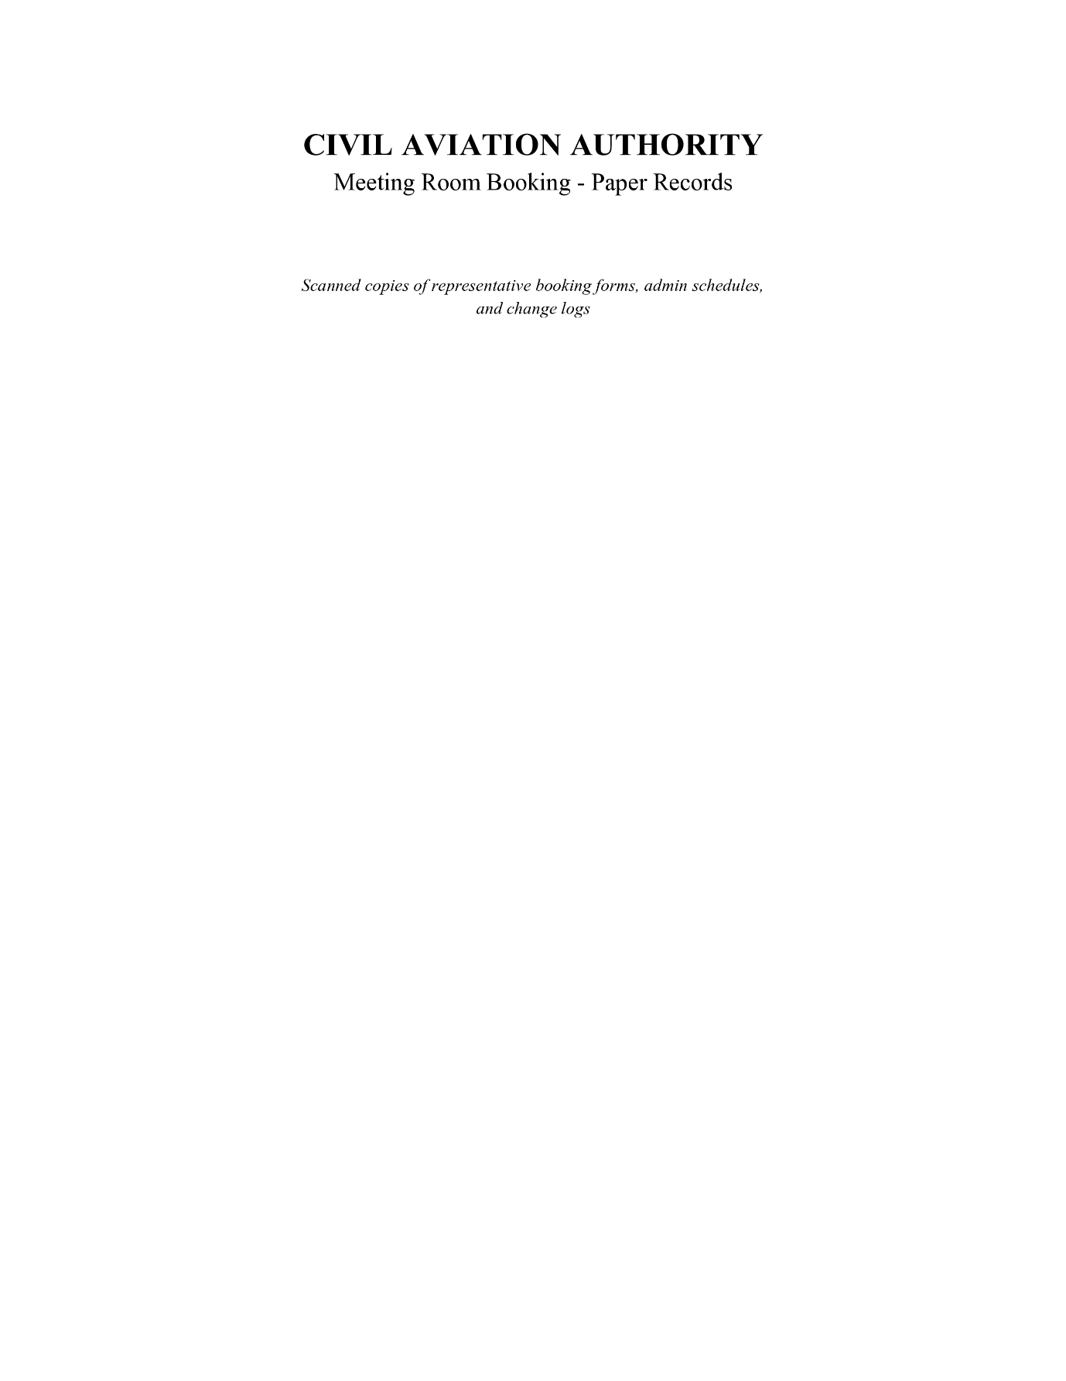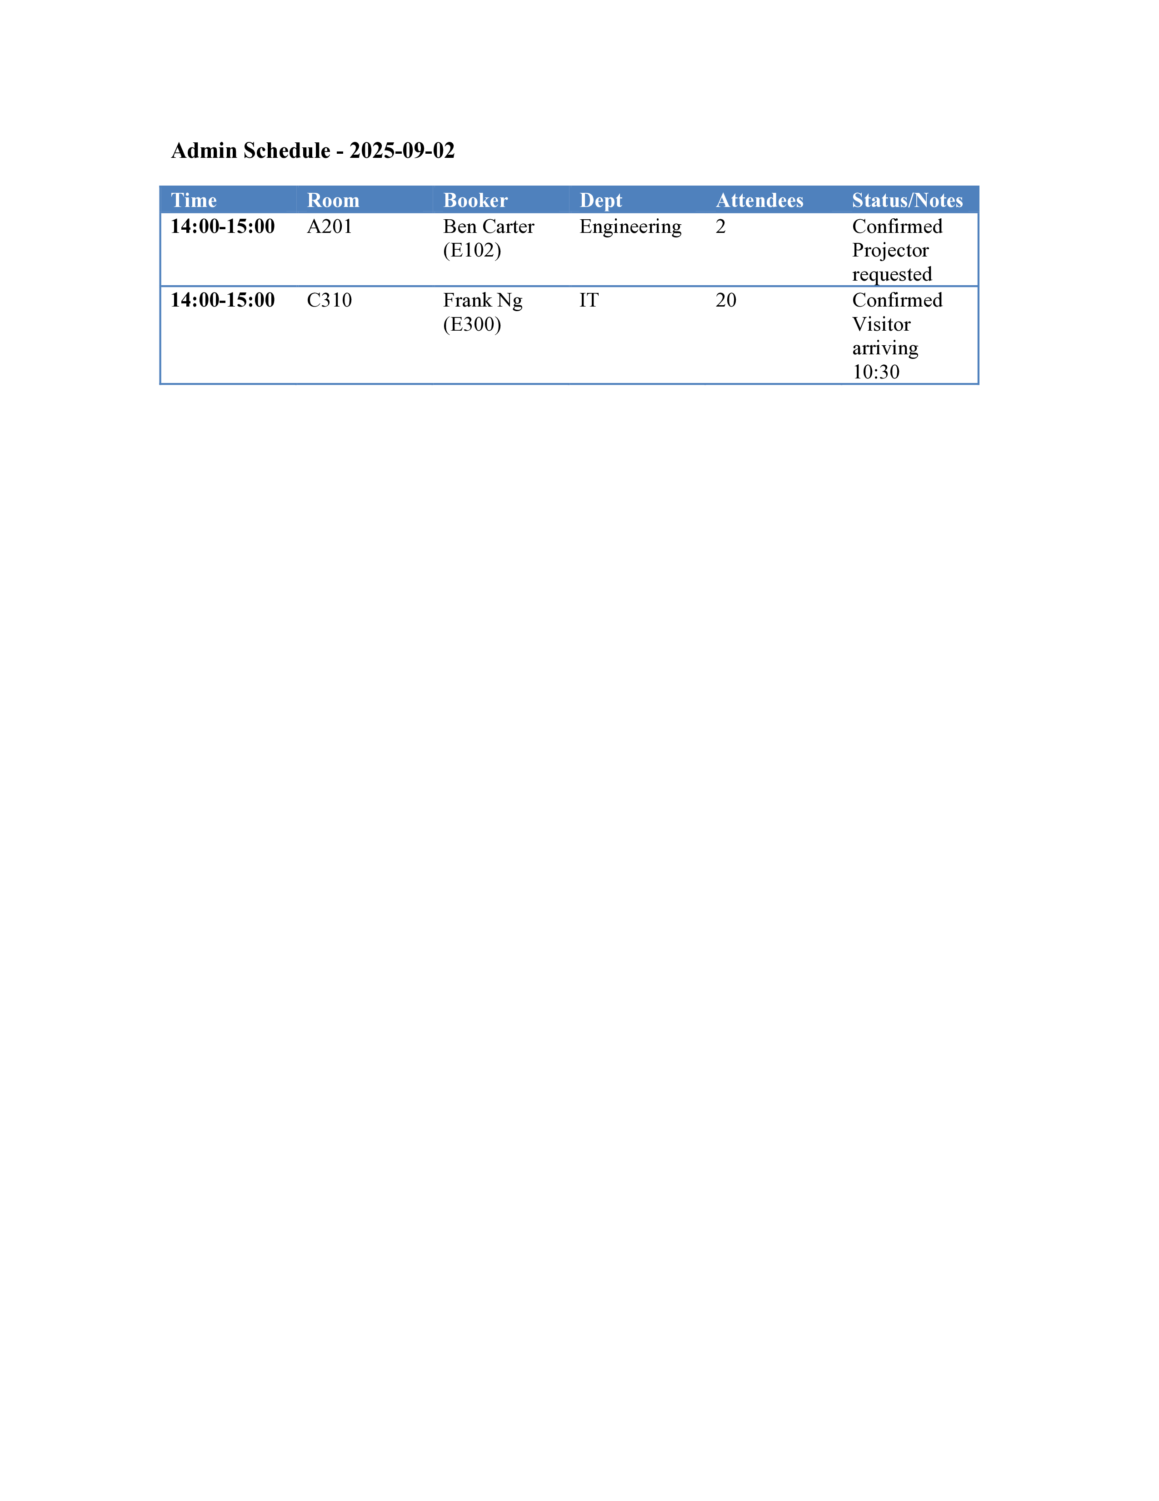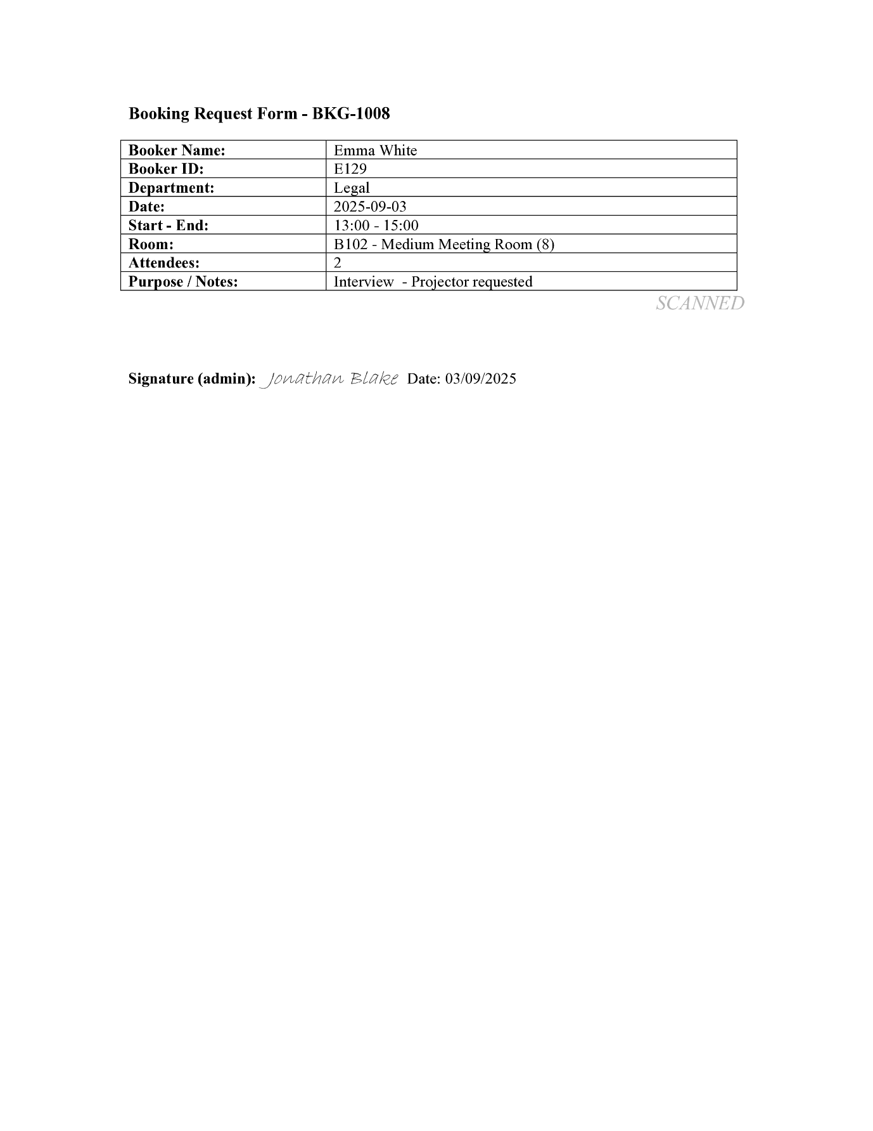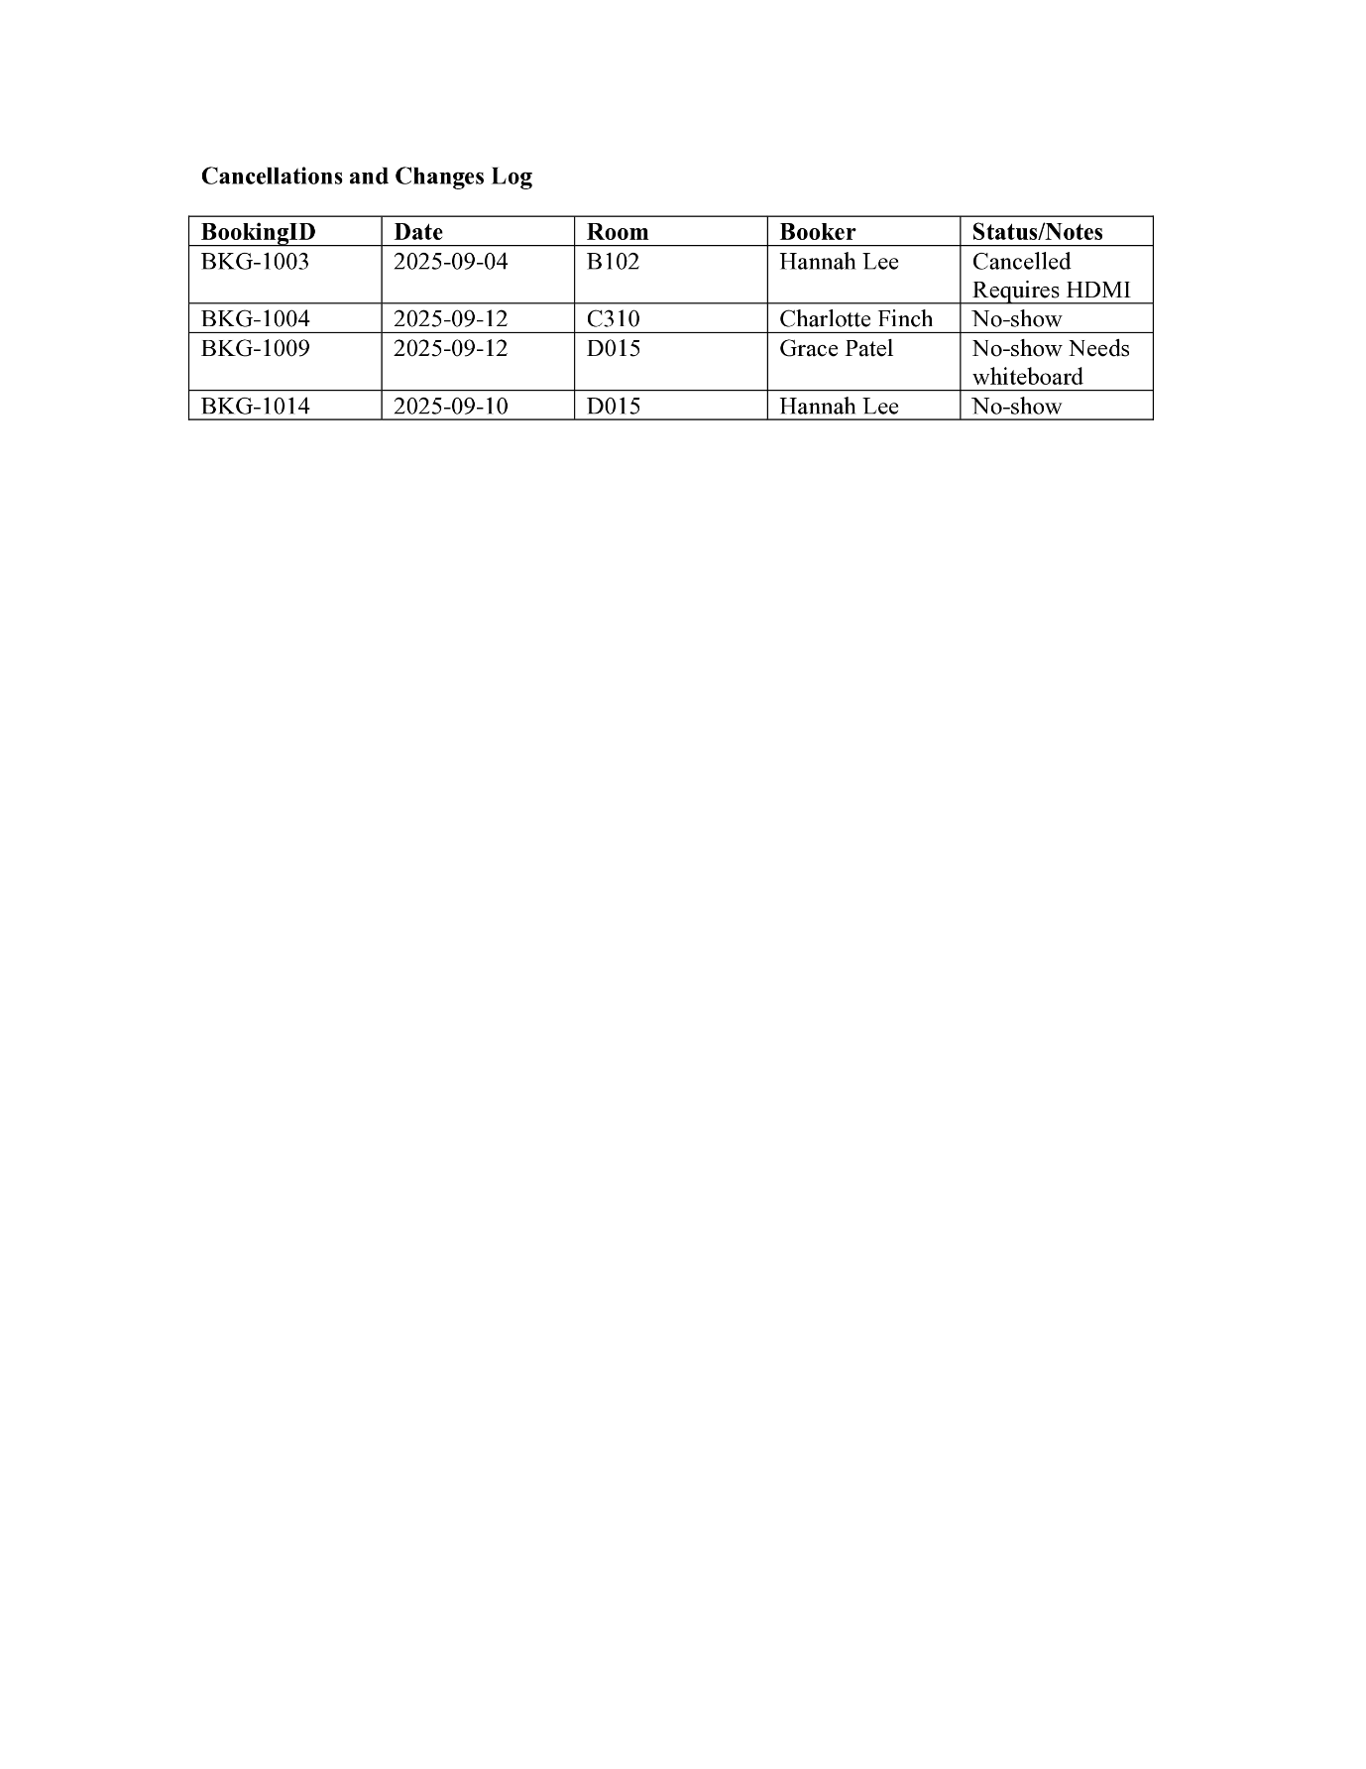

Processing
Right now, all the processing for the booking system is done manually by the admin staff. When someone wants a meeting room, they either send an email, fill out a form, or just ask in person. The admin then must check the noticeboard or their records to see if the room is available. If it is free, they write it down on the schedule and confirm it back to the staff member, usually by email or in person. If the room is not free, they then must go back and forth suggesting other times. None of this is automated, so every step must be handled by a person. This means that double bookings happen a lot because there is no automatic conflict checking and sometimes the admin just doesn’t notice clashes. It also makes cancellations or changes more complicated, since they must manually update the schedule and make sure everyone involved knows about it. Overall, the processing is very time consuming, repetitive, and leaves a lot of room for human error.

Limitations
The current system has quite a few limitations that cause problems for both staff and admins. The biggest one is that there is no live way for staff to see what rooms are free. They either must ask an admin or check the noticeboard, which might already be out of date. Another limitation is that errors are quite common, especially double bookings or lost requests, since everything depends on someone updating the schedule correctly every single time. It also creates a huge workload for the admin staff, who spend far too much of their time just managing bookings instead of doing other tasks. On top of that, there is no centralised record that staff can access, so cancellations and changes are often missed or forgotten, leading to confusion. Altogether, these limitations make the entire system inefficient and frustrating to use, which is exactly why a digital system is needed.

Working specification
The new system will be a digital meeting room booking platform that staff can access through the CAA internal network on any company device. It will let staff log in, see which rooms are available in real time, and then book, cancel, or change their bookings without needing to go through an admin. To make sure bookings are reliable, the system will automatically check for clashes and stop double bookings from happening. There will also be a physical check-in screen outside each meeting room where staff can scan their ID or use NFC to confirm they are using the room. Managers will have extra permissions to override bookings if they need to, while general staff will just be able to manage their own. The overall aim is for the system to be simple to use, cut down the workload on the admin staff, and make the whole booking process more reliable and efficient.

Justifications of the methods to be used.

What language are you planning on using and why?
For the programming language, I will be using Python because it is the one I have the most experience with. This means I will be able to work more confidently and solve problems faster. Python also has an exceptionally large community, so if I do get stuck there will be lots of resources and support available online. Since the system does not need to run extremely fast, there are no real downsides in terms of speed, and Python is extremely easy to deploy compared to some other languages.

What libraries will you be using and why?
For libraries, I will be using Flask as the web framework because it is lightweight, simple to use, and perfect for building small to medium-sized web apps like this. With Flask I will also be using Jinja2, which allows me to create templates and display dynamic content in the web pages. For the database side, I will use SQL alchemy as it’s a nice way of interacting with databases particularly SQLite and to keep the code as purely python as possible to take advantage of all the integration features.

What methods are you planning on using?
The methods I plan to use include connecting the web application to the database, sending data from the website to be stored, and retrieving that data when it needs to be displayed back to the user. For example, when someone books a room, the data will be taken from the form on the website and saved in the database, and then when staff want to check room availability the system will pull the relevant information from the database and display it. These methods will cover all the basic functionality needed to make the system work as intended.

What SQL platform are you planning on using and why?
For the SQL platform, I have chosen SQLite along with SQL alchemy because they both are quite easy to set up and use. Unlike other database systems that require a server, SQLite is file-based, which makes it simple to share the code, submit the project, and deploy it without extra setup. It is also fast enough for this project, and since there will only be one writer at a time, the single write limit that SQLite has is not a problem. Overall, SQLite is the best choice for this system because it balances simplicity and functionality. SQL alchemy is used to provide a great layer between the db and the python code (Orm/object relation mapping) so that instead of when querying the db and having to write pure SQL in comments, I can use python native features like classes to create tables and using native python types in order for the table to be more integrated into the system.

Objectives and success criteria

Objectives
- Provide staff with a digital system to view, book, amend, and cancel meeting rooms directly.
- Improve visibility by showing real-time room availability across all meeting spaces.
- Reduce admin workload by automating booking management and conflict checking.
- Support organisational hierarchy by allowing senior managers to override bookings where necessary.
- Enable on-the-spot bookings and check-ins via physical room screens.
- Centralise booking data into a single, always up-to-date platform accessible on company devices.
- Ensure compliance with GDPR by restricting access to sensitive details and securing stored data.

Success Criteria
- Staff can independently make, edit, and cancel bookings without relying on admin staff.
- Real-time room availability is displayed accurately and updated instantly.
- Double bookings and scheduling conflicts are automatically prevented.
- Admin staff workload related to booking management is significantly reduced.
- Senior managers can override bookings with logged justifications.
- On-the-spot bookings and early check-outs are possible using room screens and staff ID scans.
- The system consistently stores and displays booking data securely, in compliance with GDPR.
- Staff adoption is successful, with most employees reporting the system is simple and reliable to use.

